

Placement Empowerment Program

Cloud Computing and DevOps Centre

Set Up a Load Balancer in the Cloud :Configure a load balancer to distribute traffic across multiple VMs hosting your web application.

Name:Manashaa U Department: CSE

Introduction:

In this Proof of Concept (POC), here I have created a Load balancer to manage the inbound and outbound traffic

Step-by-Step Overview Step

1)Open azure portal

2)Go to resource and search for load balancers

3)Enter the details

4) choose “ public” for external load balancing and “internal” for internal load balancing

5)click on “create”

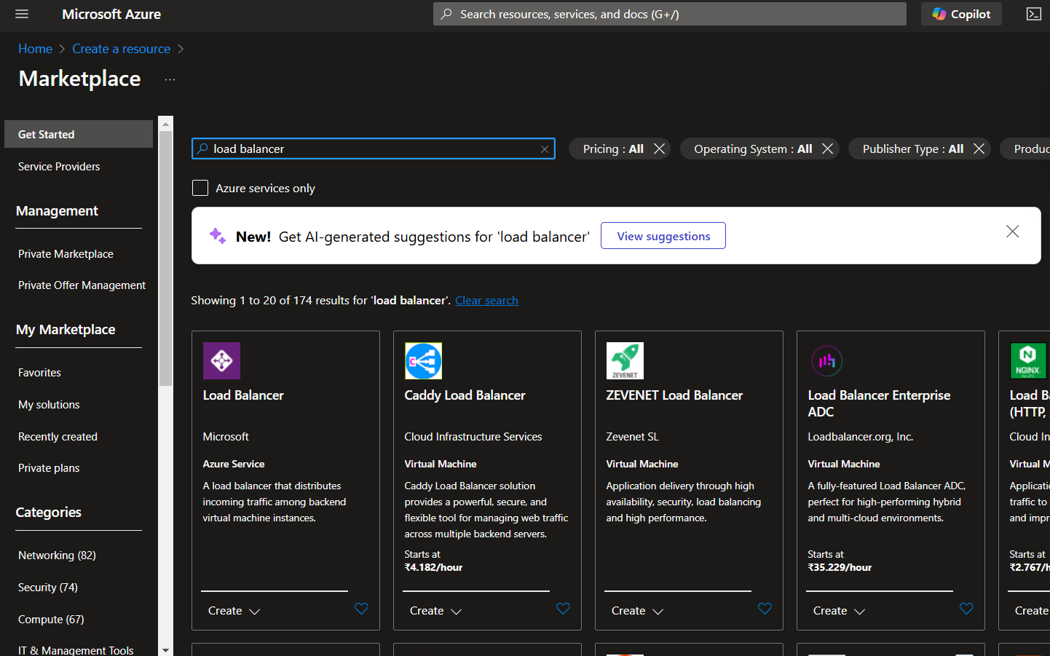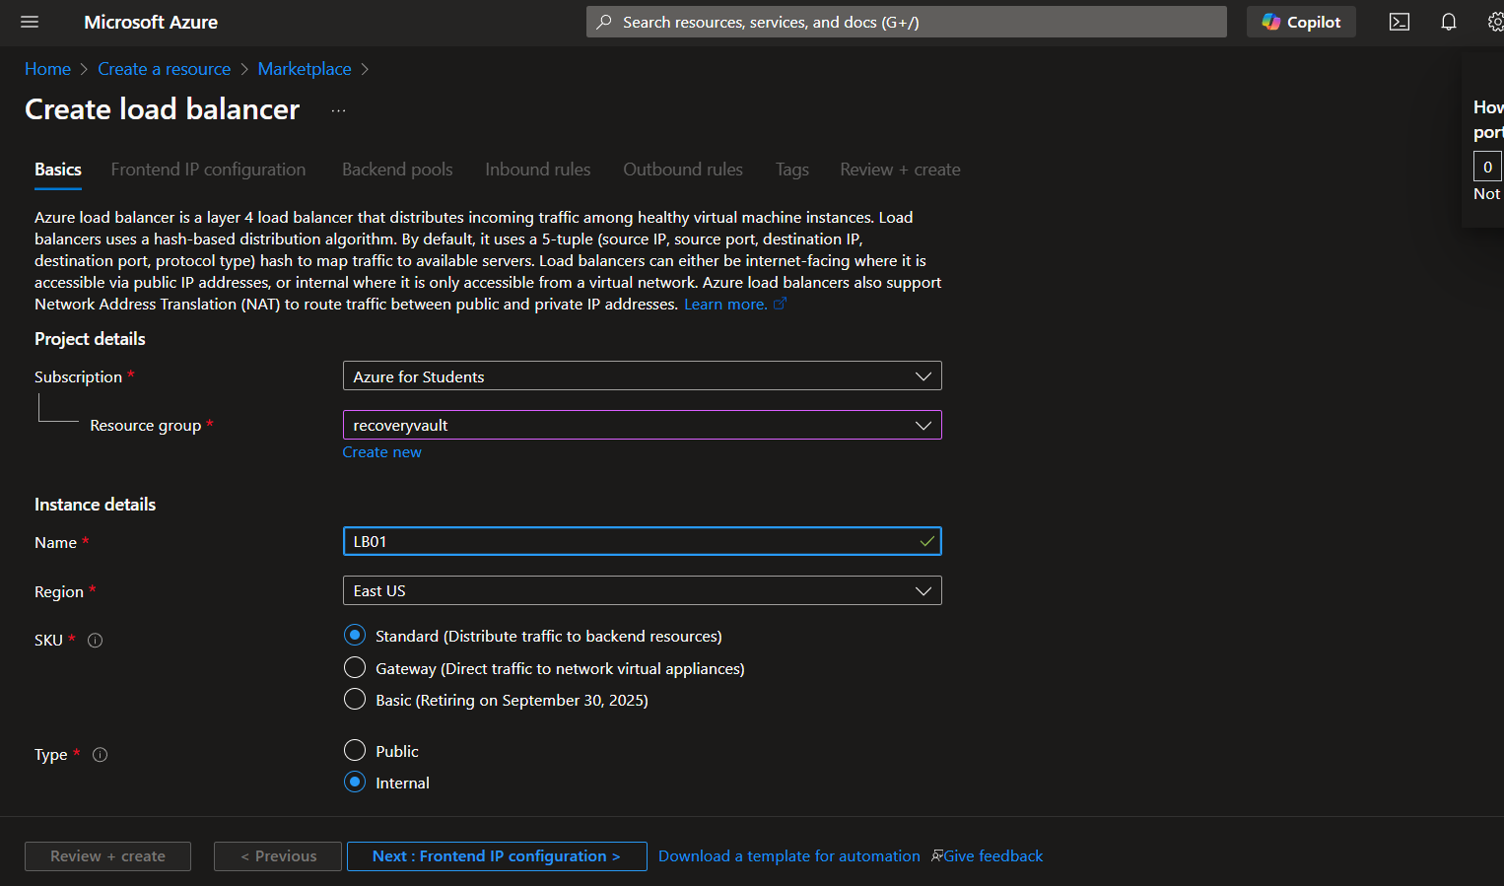

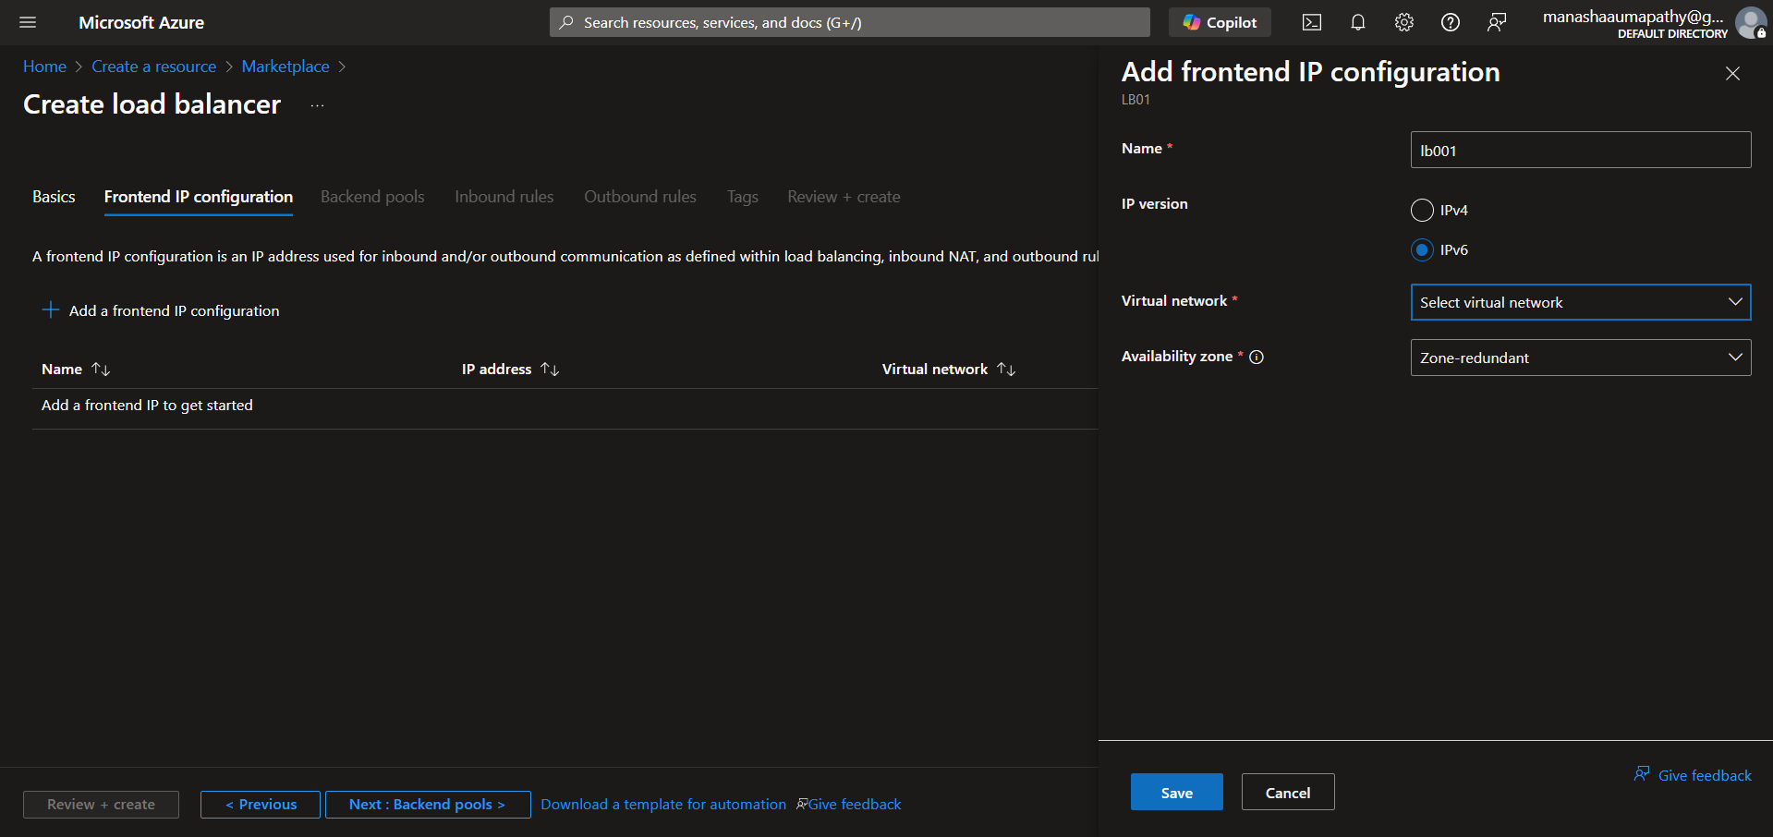

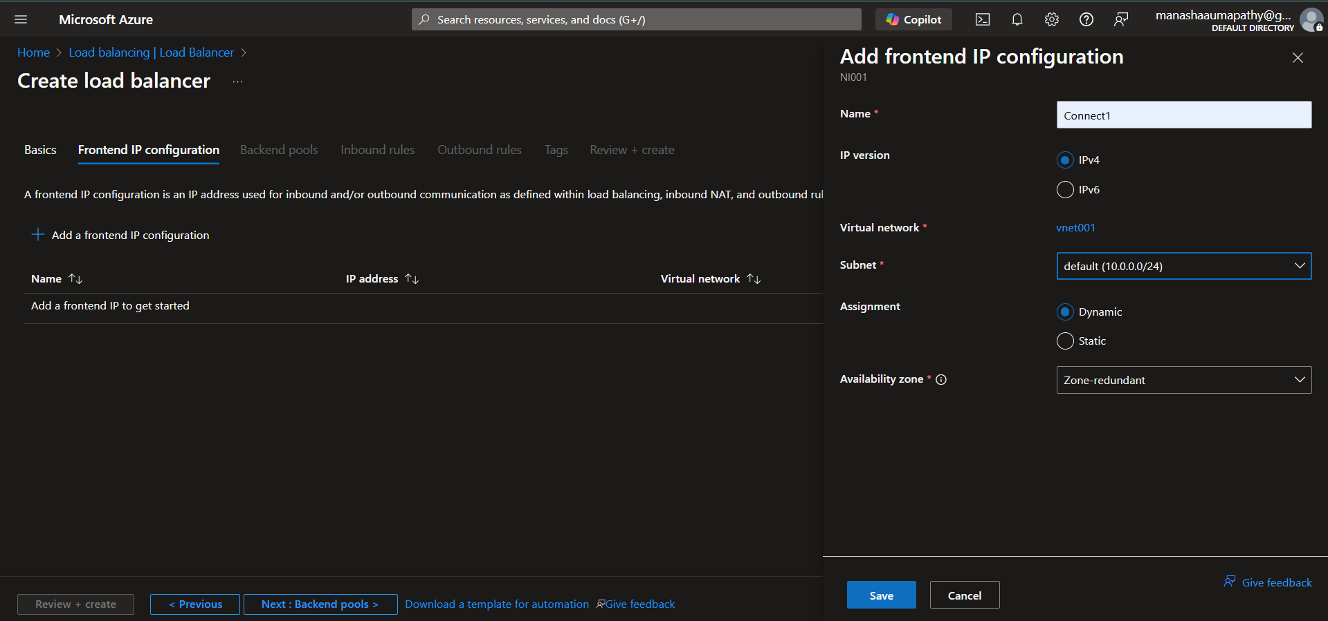

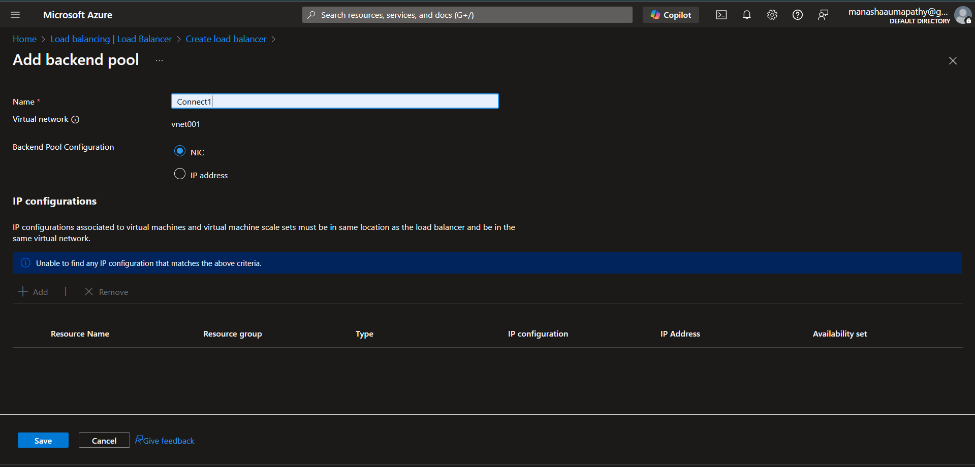

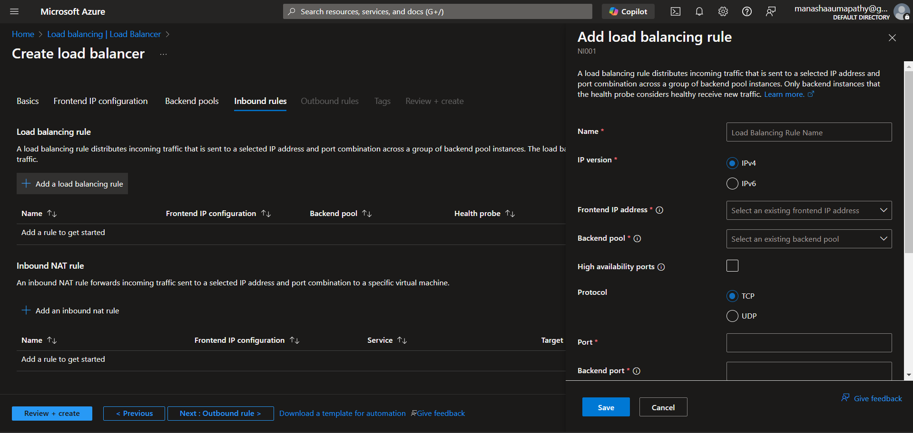

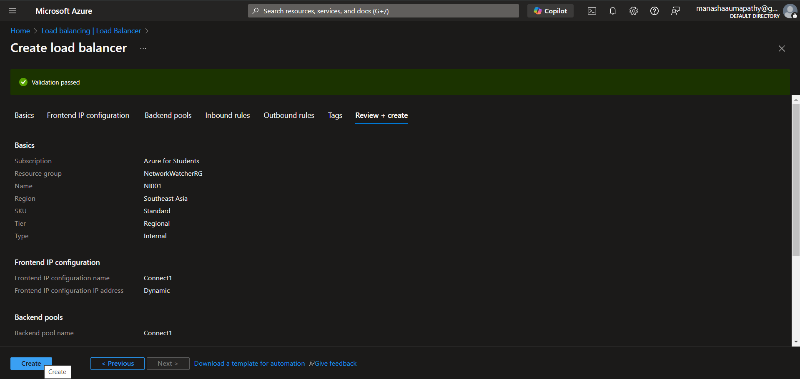

OUTCOME:

Load balancers increase the fault tolerance of your systems by automatically detecting server problems and redirecting client traffic to available servers. You can use load balancing to make these tasks easier: Run application server maintenance or upgrades without application downtime.